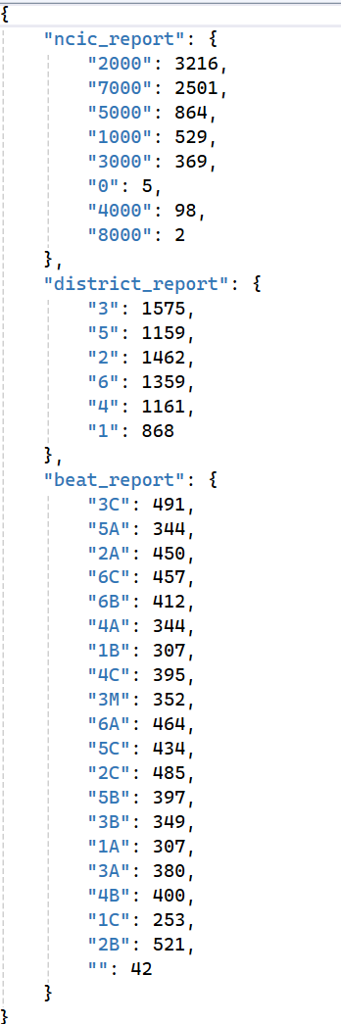Alex Krzan Crime Project

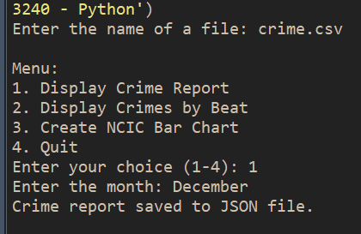

JSON File 🡪

\*\* Here are the first 16 Crimes. The list goes on to show 349 total crimes.

